Sprint 2 — Integración Supabase + lógica compleja + debugging profundo con agentes
INTEGRANTES:
URIARTE ORDOÑEZ ZAID(SCRUM MASTER)
VALENTINO CUENCAS(FRONTED)
LUIS CAJACURI(BACKEND)
ALEXANDER CARDENAS 5(BACKEND)
LINK REPOSITORIO GITHUB:
https://github.com/JesseAU/antigravity-sprint2-realtime-auth

LINK TRELLO:
https://trello.com/invite/b/699737651543f65be3ff3f8d/ATTI13b2a7984f1dd5b2c6e76e57e0b1c4f2ED5CDA15/sprint-2-integracion-supabase-logica-compleja-debugging-profundo-con-agentes

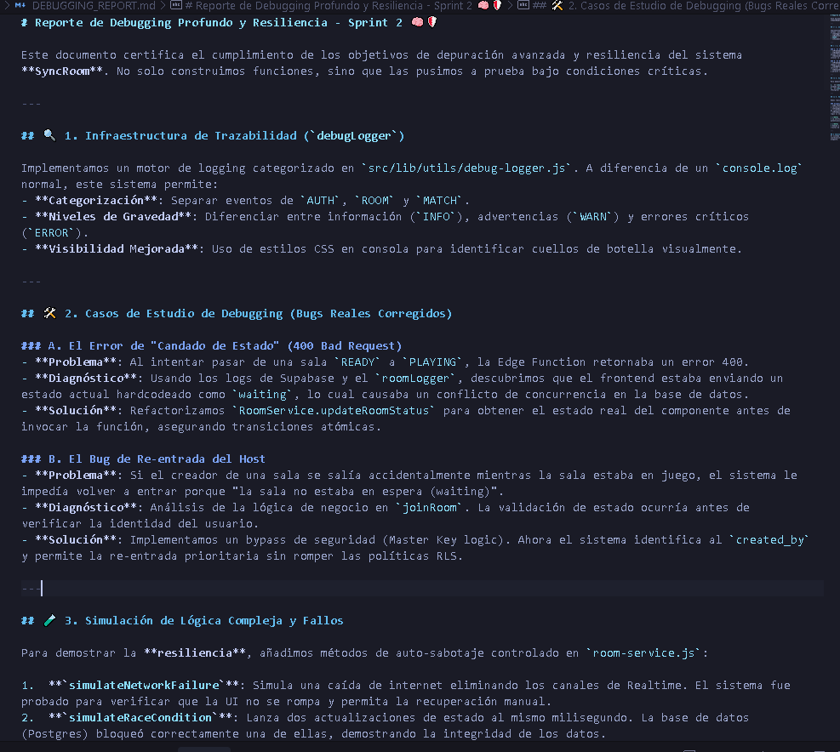
DEBUGGING GUIADO:

